**EXPERIMENT NUMBER 8**

| Name of Student: Sangeet Agrawal | PRN: 21070122140 | Section: CS-B3 |
| --- | --- | --- |

**Title:** Study of Intrusion Detection System (IDS)

**Aim:** Study and understand Snort IDS

**Objective:** To make students understand IDS and current research in IDS

**Theory:**

The goal of the Intrusion Detection Analyst is to find possible attacks against a network. Recent years have witnessed a significant increase in Distributed Denial-of-Service (DDoS) attacks on the Internet, making network security a great concern. Analysts search for possible attacks by examining IDS logs and packet captures and corroborating them with firewall logs, known vulnerabilities, and general trending data from the Internet. IDS attacks are becoming more sophisticated; automatically reasoning the attack scenarios in real-time, and categorizing them has become a critical challenge. These processes result in huge amounts of data, which analysts must examine to detect a pattern. However, the overwhelming flow of events generated by IDS sensors make it difficult for security administrators to uncover hidden attack plans.

To become an expert penetration tester and security administrator, you must possess sound knowledge of network IPSs, IDSs, malicious network activity, and log information.

**Overview of Intrusion Detection Systems**

Intrusion detection systems are highly useful as they monitor both the inbound and outbound traffic of the network and continuously inspects the data for suspicious activities that may indicate a network or system security breach. The IDS checks traffic for signatures that match known intrusion patterns and signals an alarm when a match is detected. It can be categorized into active and passive, depending on its functionality: an IDS is generally passive and is used to detect intrusions, while an intrusion prevention system (IPS) is considered as an active IDS, as it is not only used to detect the intrusion on the network, but also prevent them.

**Main Functions of IDS**:

* Gathers and analyzes information from within a computer or a network, to identify the possible violations of security policy
* Also referred to as a “packet-sniffer,” which intercepts packets traveling along various communication mediums and protocols
* Evaluates traffic for suspected intrusions and signals an alarm after detection

**Snort** is the foremost Open Source Intrusion Prevention System (IPS) in the world. Snort IPS uses a series of rules that help define malicious network activity and uses those rules to find packets that match against them and generate alerts for users.

Snort can be deployed inline to stop these packets, as well. Snort has three primary uses: As a packet sniffer like tcpdump, as a packet logger — which is useful for network traffic debugging, or it can be used as a full-blown network intrusion prevention system. Snort can be downloaded and configured for personal and business use alike.

**Detect Intrusions using Snort:** Snort is an open-source network intrusion detection system, capable of performing real-time traffic analysis and packet logging on IP networks. It can perform protocol analysis and content searching/matching and is used to detect a variety of attacks and probes such as buffer overflows, stealth port scans, CGI attacks, SMB probes, and OS fingerprinting attempts. It uses a flexible rules language to describe traffic to collect or pass, as well as a detection engine that utilizes a modular plug-in architecture.

**Uses of Snort:**

* Straight packet sniffer such as tcpdump
* Packet logger (useful for network traffic debugging, etc.)
* Network intrusion prevention system

**Tools for Study:**

1. Snort
2. HoneyBOT

**Reference web links:**

1. <https://www.snort.org/>
2. <https://download.cnet.com/Intrusion-Detection-System-SAX2/3000-18510_4-10886064.html>
3. <https://honeybot.software.informer.com/>

**Conclusion:**

**Theory question:**

1. What do you mean by Intrusion prevention system (IPS)? How IDS is different than IPS?

Answer) An Intrusion Prevention System (IPS) is a network security tool designed to detect and prevent potential threats by monitoring traffic and taking action to block attacks in real-time. It actively stops malicious activities by enforcing security policies.

In contrast, an Intrusion Detection System (IDS) only monitors network traffic and alerts administrators to potential threats but does not take direct action to prevent them. IDS is passive, while IPS is proactive in its response to threats.

| **Feature** | **IDS (Intrusion Detection System)** | **IDS (Intrusion Detection System)** |
| --- | --- | --- |
| **Action** | Detects and alerts | Detects and blocks |
| **Response** | Passive (no direct action) | Active (automatically prevents) |
| **Position in Network** | Monitors traffic | Inline with network traffic |
| **Impact on Traffic** | No effect on traffic flow | Can impact traffic by blocking threats |
| **Main Purpose** | Alert administrators of suspicious activity | Prevent attacks in real-time |

1. Configuration and demonstration of Snort

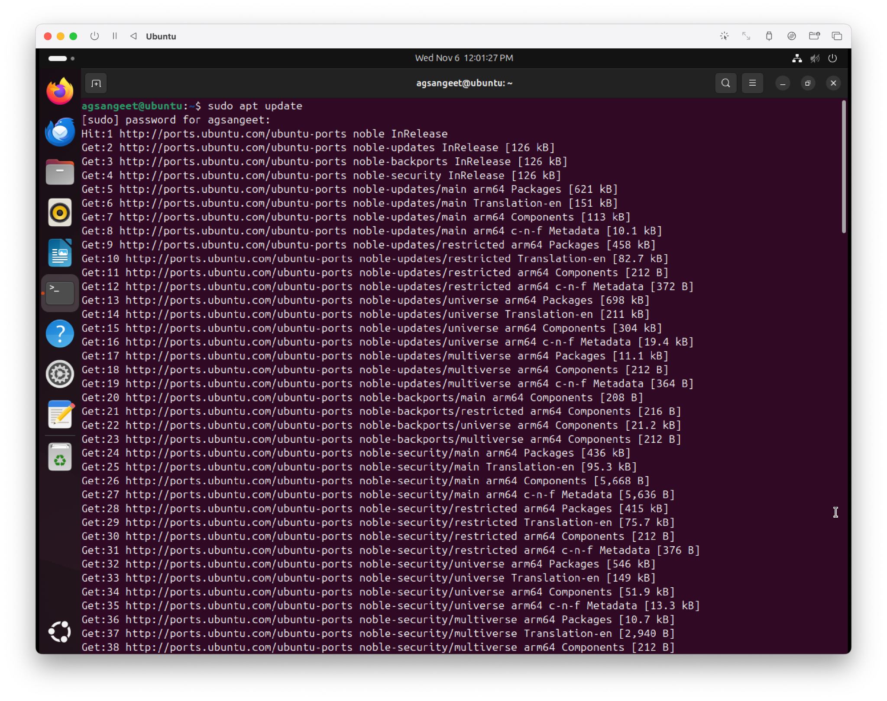

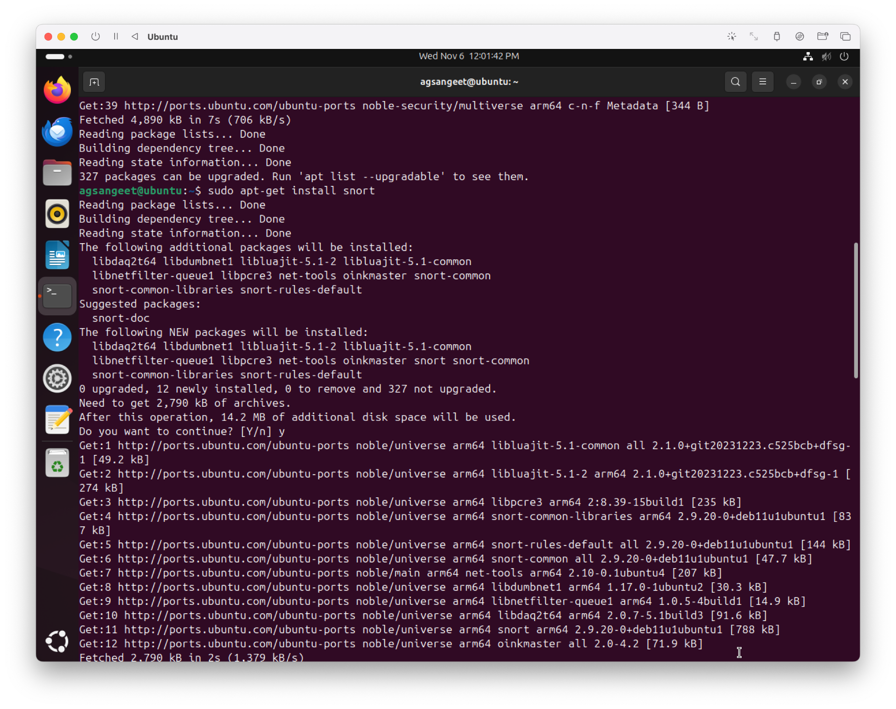

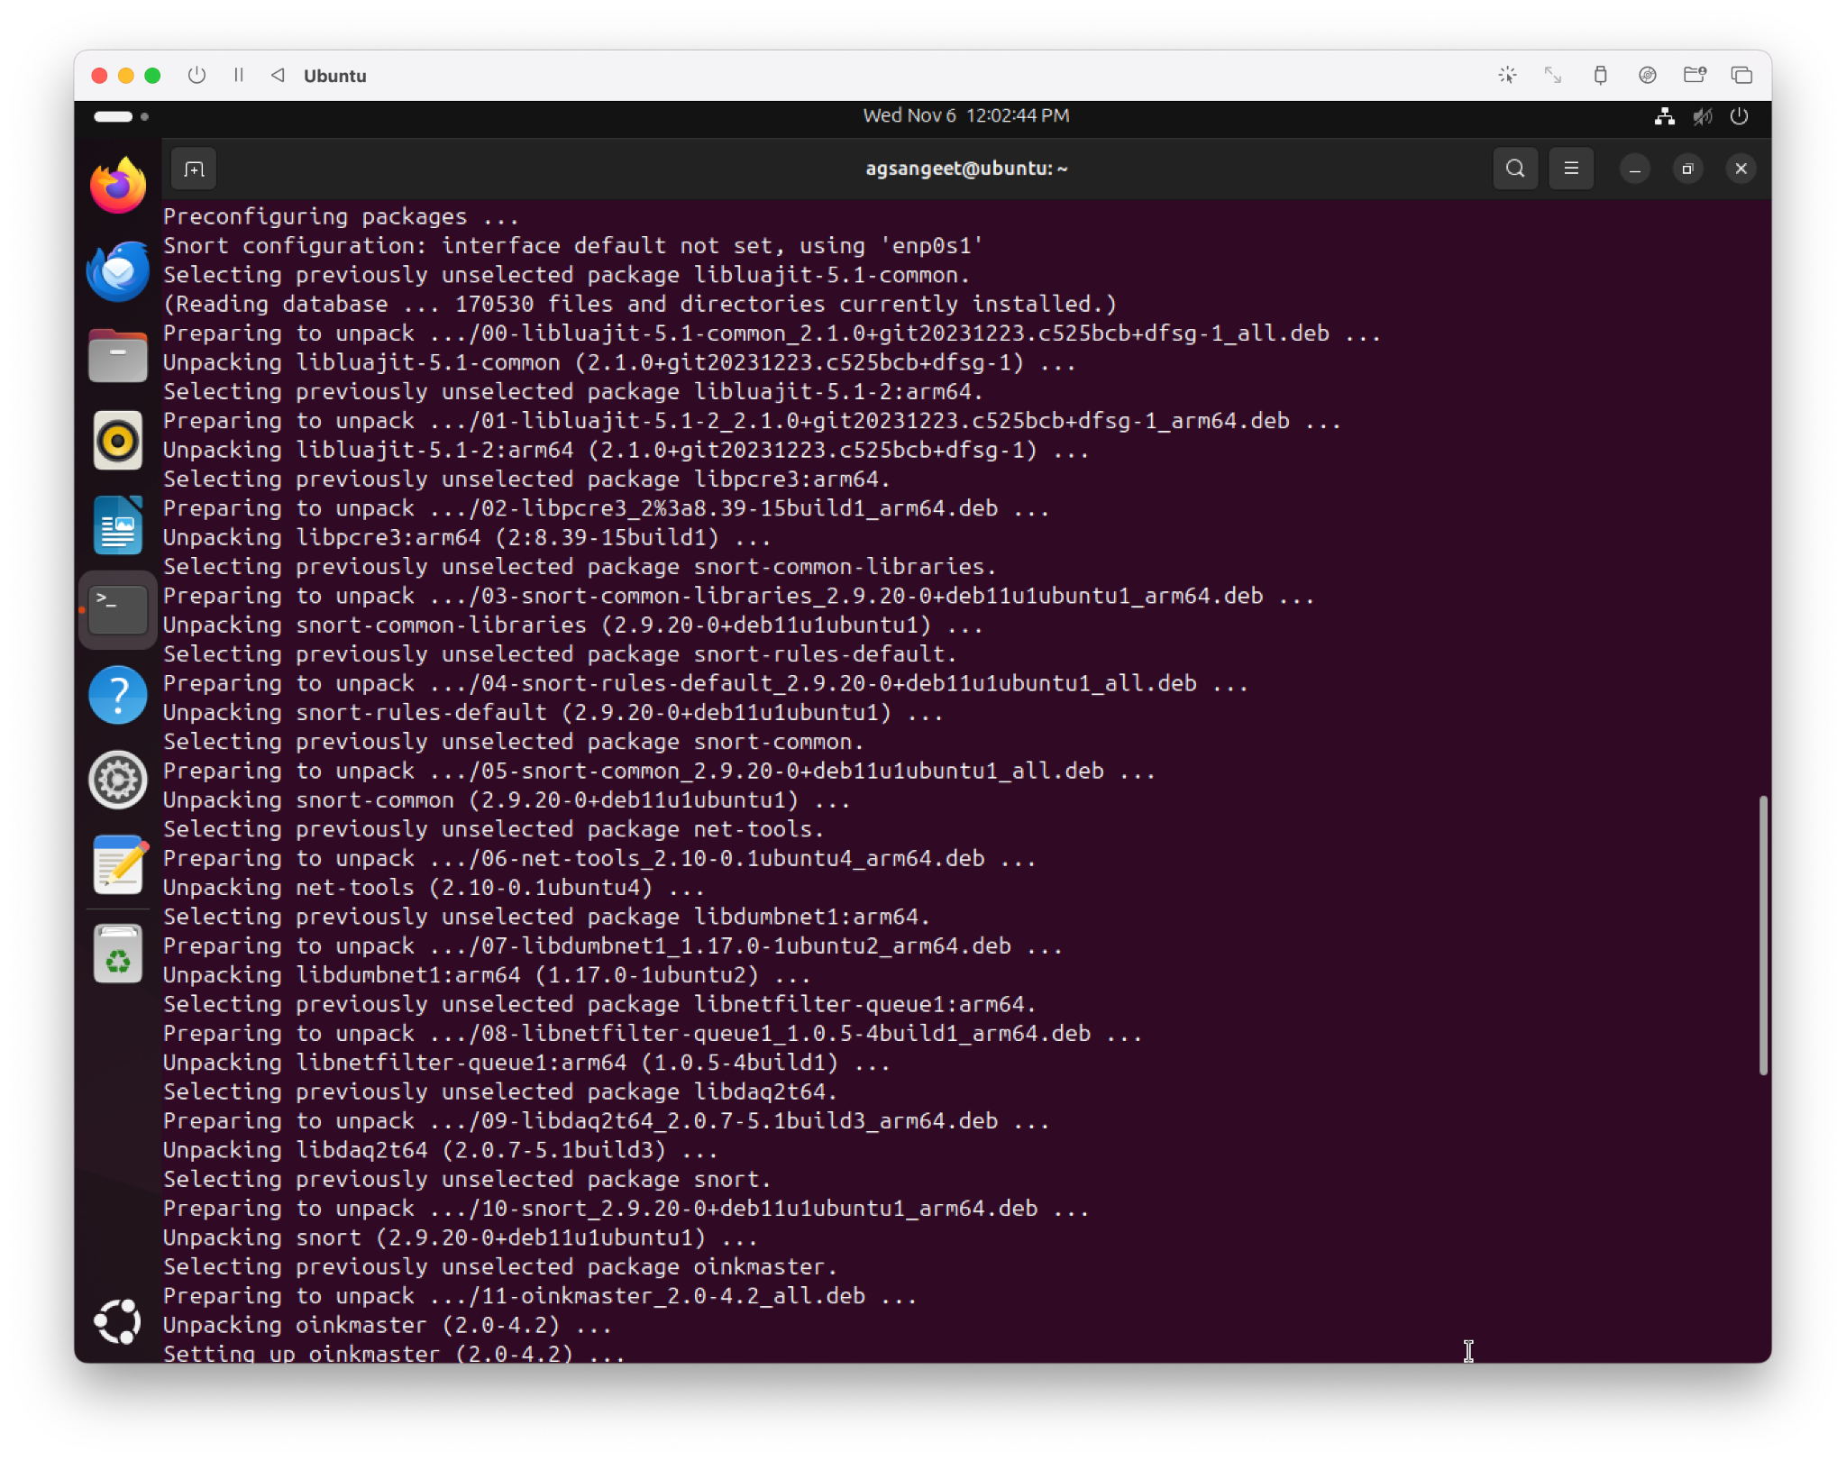

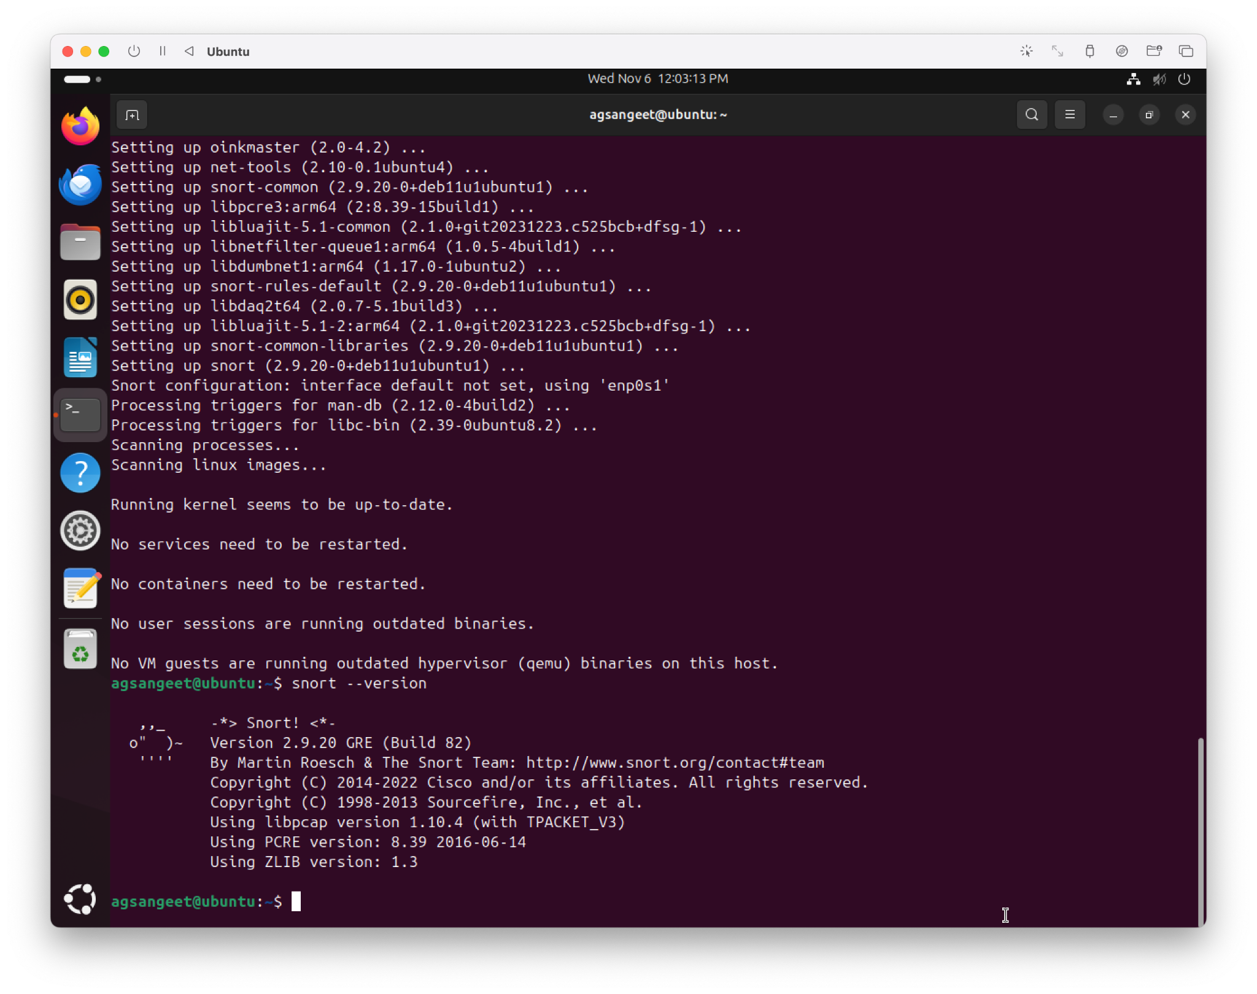

To quickly capture packets and alert on suspicious behaviour: (The process is slow)

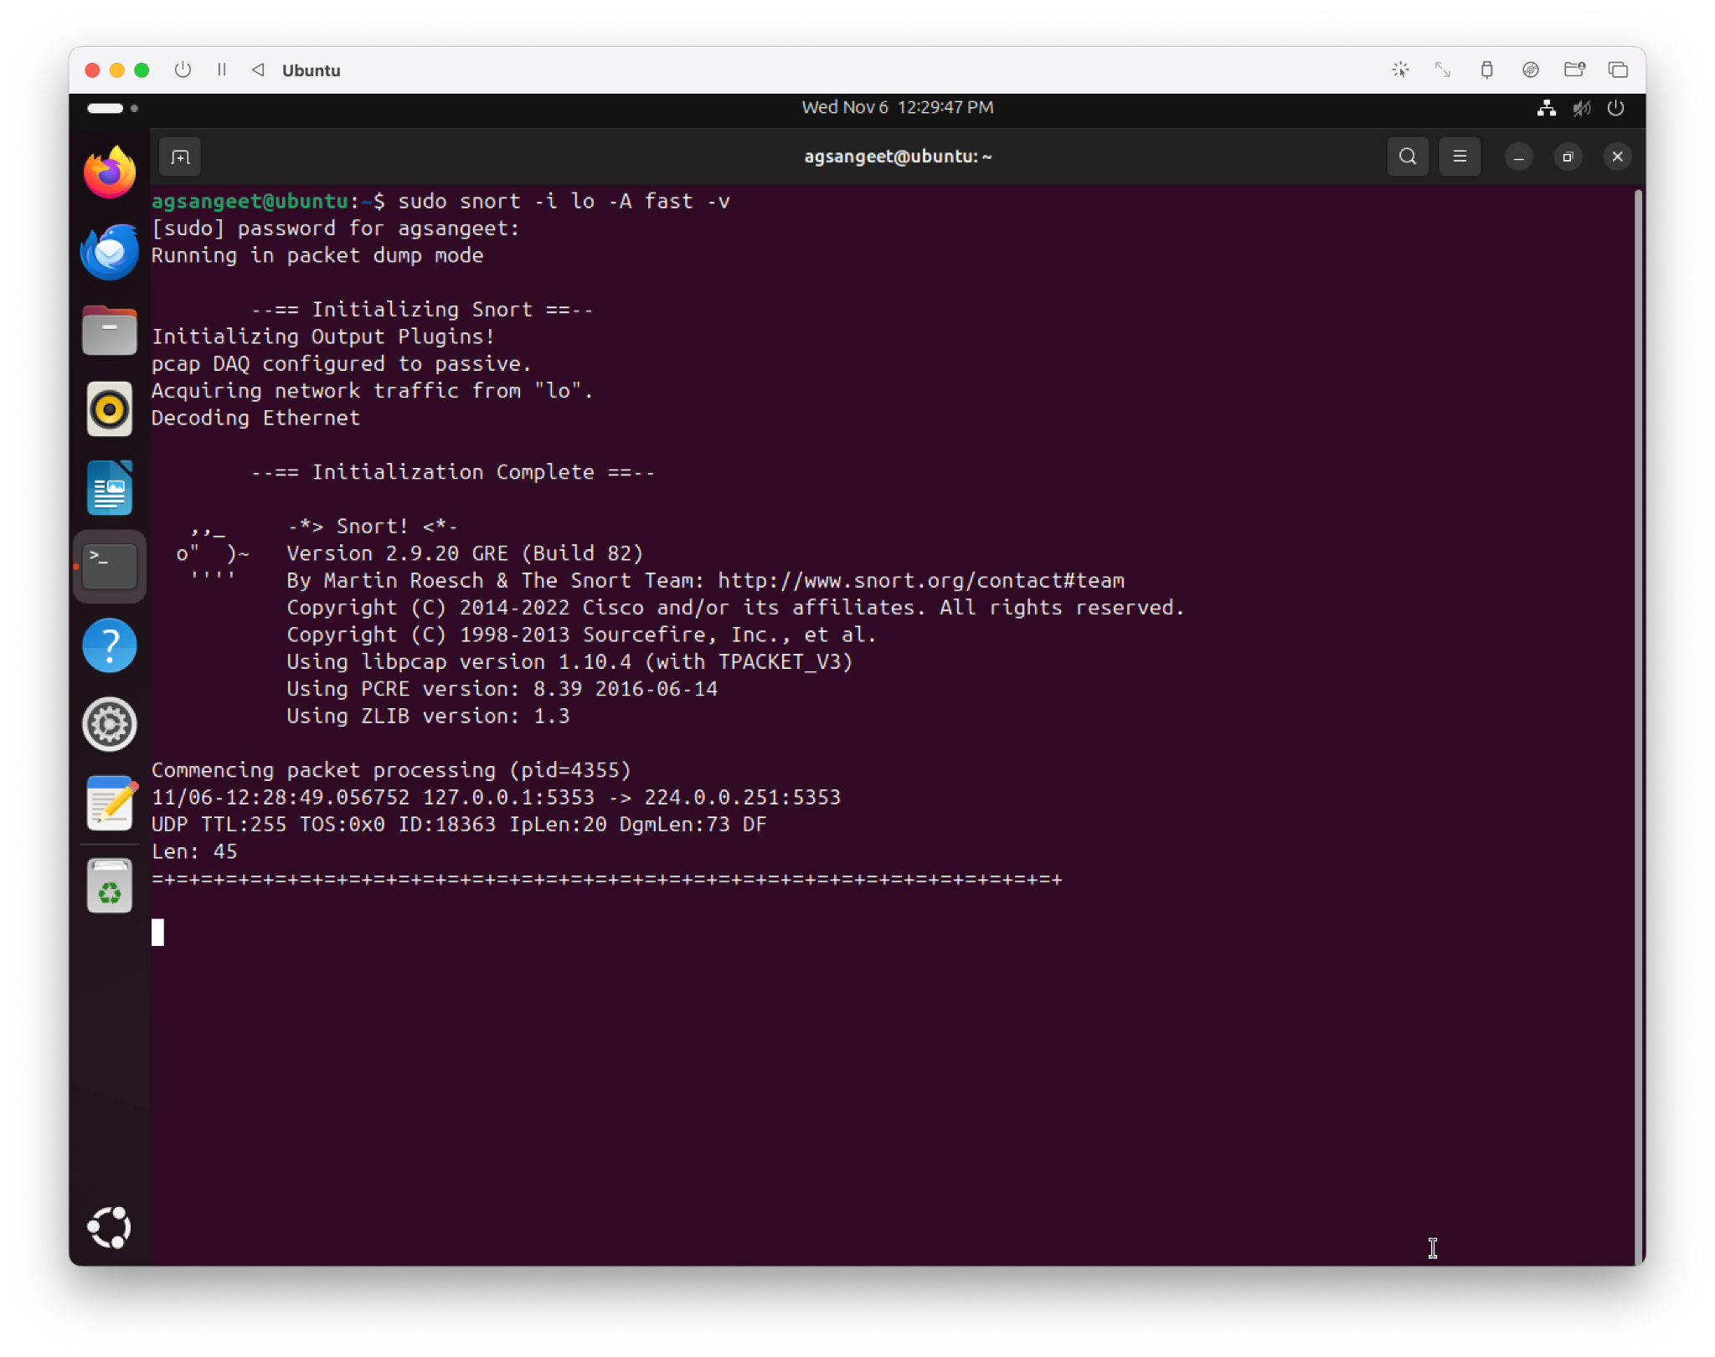

**Note:** Students are suggested to use Linux OS-based tools or free Windows OS-based tools.